

**East West University**

**Department of Computer Science & Engineering**

**Course Code :** CSE251

**Course title :** Electronic Circuits

**SEC :** 1

**Lab Report**

**Experiment Number :** 01

**Experiment Title :** I-V Characteristics and Modeling of Forward Conduction of a Diode.

**Submitted to:**

Surajit Das Barman

Senior Lecturer,

Department of Computer Science and Engineering

**Submitted by:**

**Group No:**

1. NAME: Shaykh Siddique ID: 2016-1-60-053
2. NAME: Noor - E- Jannat ID: 2016-1-60-067
3. NAME: Jannatun Naym ID: 2016-1-60-119
4. NAME: Sabikun Naher ID: 2017-1-60-020

**Date of Performance :** 17-05-2018

**Date of Submission :** 24-05-2018

**Experiment No:** 01

**Experiment title:** I-V Characteristics and Modeling of Forward Conduction of a Diode.

**Objectives:**

1. To measure the I-V characteristics of forward conduction of a p-n junction diode.

2. To determine the models of forward conduction of a p-n junction diode.

**Introduction:**

Diode in one of the most basic non-linear electronic devices. An ideal diode acts like a switch for electrical current, acting as a short circuit for current flow in one direction (forward bias connection) while behaving as an open circuit for current flow in the opposite direction(reverse bias connection). The characteristics of practical diodes are however somewhat different from those of ideal ones. The p-n junction diodes are one of the most popular types of diodes used in the industry. The forward bias current-voltage (I-V) characteristic of a p-n junction diode will be measured in this experiment.

**Circuit diagram**



**Figure:** Circuit set up to measure forward bias I-V characteristics of a diode

**Equipments and Components used:**

1. DC power supply
2. Digital multimeter
3. Diode (1 pc)
4. Resistor 1KΩ
5. Breadboard
6. Connecting wires
7. Matlab
8. PSpice

**Lab procedure:**

1. Measure the resistance value of figure 1 with the multimeter and write it down in KΩ in Table.
2. Connect the circuit as shown in Figure. Use the DC power supply unit as DC source.
3. Change the DC source and measure the values of VD and VR and write them in Table.
4. Divide VR by the measured value of resistance in KΩ. This is diode current ID in mA.

Table:

|  |  |  |  |  |
| --- | --- | --- | --- | --- |
| VDD (V) | VD (V) | VR (V) | ID (mA)=VR/R | Measured Value of R KΩ |
| 0.1 | 0.1015 | 0 | 0 |  |
| 0.2 | 0.1591 | 0 | 0 |  |
| 0.3 | 0.2527 | 0.0001 | 0.0001037 |  |
| 0.4 | 0.3340 | 0.0009 | 0.0009336 |  |
| 0.5 | 0.4495 | 0.0216 | 0.224 |  |
| 0.6 | 0.4907 | 0.0762 | 0.0790 |  |
| 0.7 | 0.5127 | 0.1454 | 0.1508 |  |
| 0.8 | 0.5262 | 0.2209 | 0.2291 |  |
| 0.9 | 0.5409 | 0.3467 | 0.3590 | 0.964 |
| 1 | 0.5517 | 0.4643 | 0.4816 |  |
| 1.5 | 0.5768 | 0.8898 | 0.9230 |  |
| 2 | 0.5954 | 1.4202 | 0.9358 |  |
| 2.5 | 0.6086 | 1.8931 | 0.9264 |  |
| 3 | 0.6218 | 2.461 | 2.5529 |  |
| 3.5 | 0.6295 | 2.875 | 2.9823 |  |
| 4 | 0.6387 | 3.379 | 3.5051 |  |
| 4.5 | 0.6459 | 3.785 | 3.9263 |  |
| 5 | 0.6521 | 4.367 | 4.5394 |  |
| 5.5 | 0.6578 | 5.006 | 5.1929 |  |
| 6 | 0.6626 | 5.261 | 5.4574 |  |
| 6.5 | 0.6678 | 5.829 | 6.0466 |  |
| 7 | 0.6738 | 6.209 | 6.4408 |  |
| 7.5 | 0.6771 | 6.866 | 7.1220 |  |
| 8 | 0.6803 | 7.334 | 7.0678 |  |
| 8.5 | 0.6843 | 7.851 | 8.1441 |  |
| 9 | 0.6873 | 8.354 | 8.6659 |  |
| 9.5 | 0.6900 | 8.854 | 9.1846 |  |
| 10 | 0.6930 | 9.295 | 9.6421 |  |
| 10.5 | 0.6971 | 9.962 | 10.3340 |  |
| 11 | 0.6981 | 10.243 | 10.6255 |  |
| 11.5 | 0.7009 | 10.901 | 11.3080 |  |
| 12 | 0.7027 | 11.267 | 11.6970 |  |
| 12.5 | 0.7054 | 11.816 | 11.9572 |  |
| 13 | 0.7078 | 12.379 | 12.8412 | 0.964 |
| 13.5 | 0.7094 | 12.789 | 13.2665 |  |
| 14 | 0.7121 | 13.267 | 13.7842 |  |
| 14.5 | 0.7135 | 13.859 | 14.3765 |  |
| 15 | 0.7158 | 14.091 | 14.6172 |  |

**Questions:**

1. Using MATLAB, plot the I-V characteristics of the p-n junction diode in forward conduction. Label the axes appropriately and have it printed.

**Answer:**

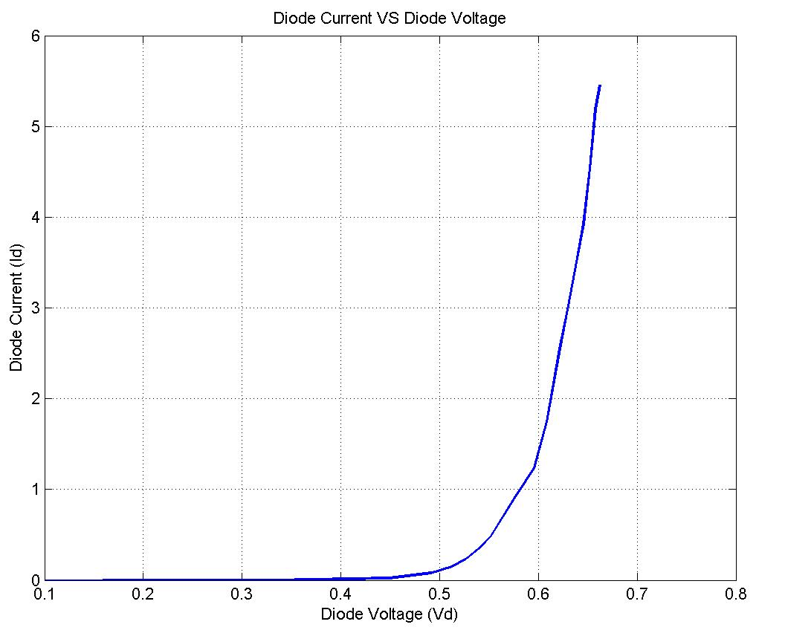

1. Use pencil to identify the points on your graph that are corresponding to ID = 2 mA and ID = 2.5 mA. Use these data points to calculate the diode parameters  and  from the equation. Use VT = 0.0259V.

**Answer:**

Given,

I1=2mA, I2=2.5mA, VD1=0.61V and VD2=0.623V.

We know,

VD2-VD1=n × VT × ln(I2/I1)

=> 0.623-0.61 = n × 0.0259 × ln(2.5/2)

So, n = 2.249.

Again, ID1= IS × exp(VD1/nVT)

=> 2 = IS ×exp(0.61/2.249*0.0259)

So, IS = 5.662 × 10-5

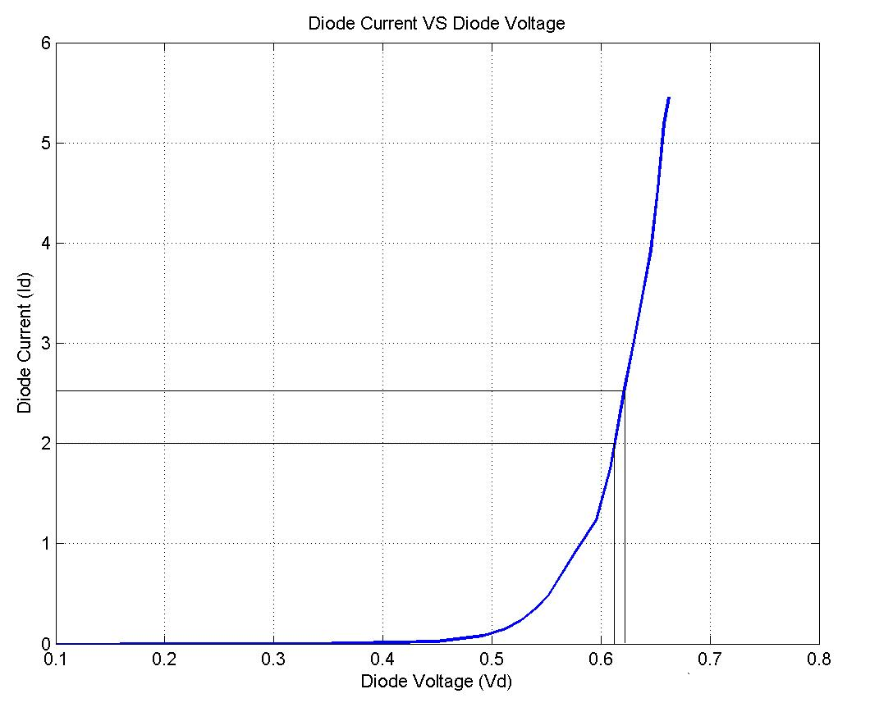

1. Determine the cut-in voltage from the printed graph by drawing extrapolated line with pencil.

**Answer:**

The cut-in voltage from the printed graph is 0. 6626V.

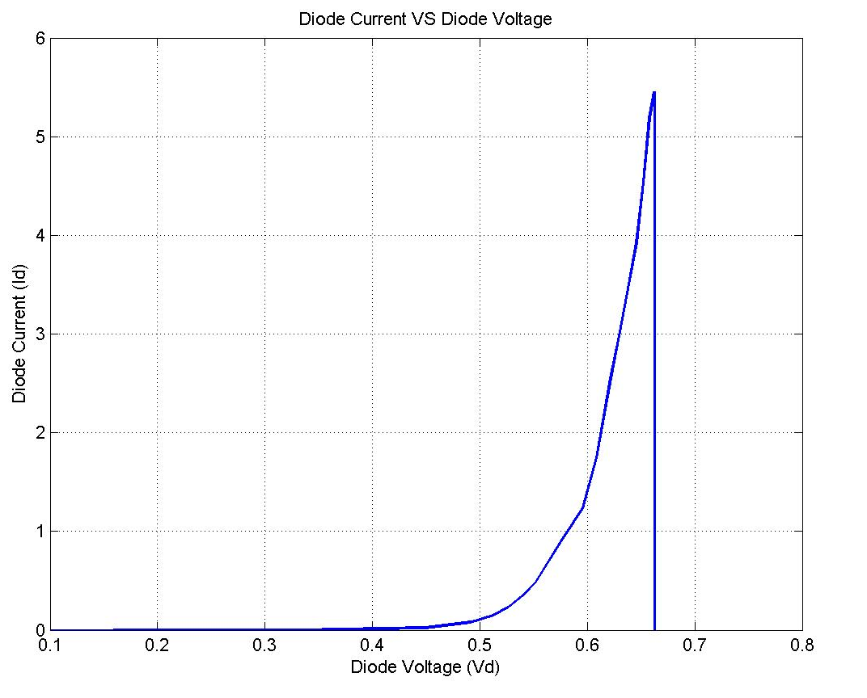

1. If the diode resistance for the piecewise linear model is defined as , calculate the value of  from the data points corresponding to ID = 2 mA and ID = 2.5 mA.

**Answer:**

1/ $r_{D}$ = (ID1- ID2) / (VD1 -VD2)

ID1 = 2.5 mA and VD1 = 0.623 V

And for ID2 = 2.0 mA and VD2 = 0.61 V

So, rD = 0.026 k ohm.

1. Simulate the circuit of Figure 1 for a DC bias (VS) range of 0-5 volts using PSpice. Print the ID vs. VS and VD vs. VS plots generated by PSpice and attach them with your report. For simulation, use the DC SWEEP option of PSpice and the diode D1N4148. To modify the diode parameters, select the diode (it will turn red) and go to Edit🡪Model🡪Edit Instance Model (Text). There, replace the values of IS, N, Vj by your values calculated in steps 2 and 3 and click OK.

**Answer:**

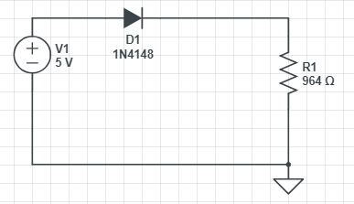

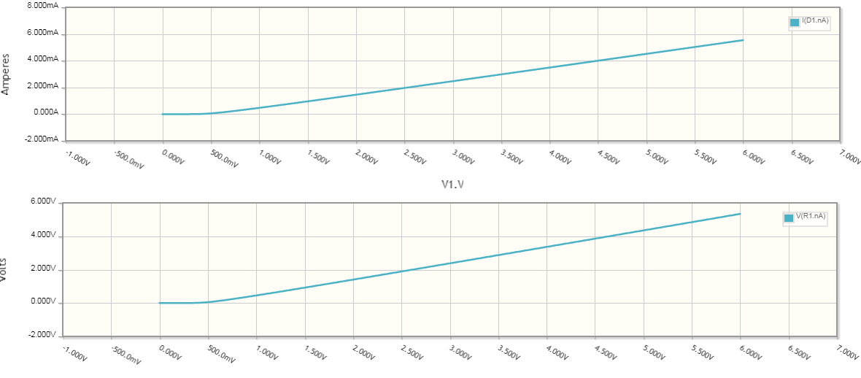

**Conclusion:**

1. After this experiment, we have learnt how to calculate the diode parameters $I_{S}$, how to determine cut-in voltage from the printed graph and how to determine $r_{D}$.